Pragmatic Auditory Scan Communication Book
This pragmatic auditory scan communication book has been adapted from the work of Gayle Porter.
Porter, G. (2007). Pragmatic Organisation Dynamic Display (PODD) communication books: Direct access templates. Melbourne: Cerebral Palsy Education Centre.
The communication book is designed to be read aloud by the communication partner. When the person who is using the book to communicate hears the option they want to communicate, they indicate “yes” in some way. Try and read aloud the options in a neutral voice. When an option is selected, you could repeat the word or phrase selected in a livelier voice. You will see examples of this in the videos below.
Assembly Instructions
- Begin by personalising the vocabulary within the book.
- You will find it easier if you keep to the structure provided, but anything can be changed.
- If you add another page to a category, keep the tab in the same place and add the appropriate letter to the numbered category e.g. if you added a page of respite friends to the category ‘People’ you could label it ‘8c. Respite friends’ and then copy the structure of the existing pages 8a / 8b.
- Page 18 is a spelling page and should be replaced with an alphabet chart that is familiar to the person who is communicating - see www.acecentre.org.uk for a range of alphabet charts if required.
- Update the instructions along the top on each page with guidance on how the person communicates “yes”. If you make any other amendments to the instructions, ensure these are replicated on every page.
- Print out each page. You could consider using tearproof / waterproof paper.
- Optional: On the right-hand side of each table there is a coloured square containing a number. This tells you what page you are on and is intended to be used as a tab. You could cut round this.
- Optional: You could then laminate the pages and cut round the tab again. Ideally use a matt laminate pouch.
- Hole punch and place in a binder or secure the pages together in some other way.
You can view videos of similar books being used on the Ace Centre’s YouTube page – www.youtube.com/acecentre. Alternatively scan these codes to go directly there:
Ruben shares a special moment: |  | A demonstration of modelling with an auditory scan book:
A wide range of alternative paper-based communication tools are available at www.acecentre.org.uk. Please also visit the website for more information about developing, using and supporting communication books or use the free advice line 0800 080 3115.
Read out loud the following list from top to bottom.
Read each word/ sentence exactly as written.
I will [insert individual’s ‘yes’ response] to indicate the word I want to say.
Turn to the page number on the right to hear more of my message.

 |  |  |  |  | 1
Quick chat |  | go to 2
Something’s wrong |  | go to 3
I don’t like this |  | go to 4
I like this |  | go to 5
Categories |  | go to 7
I want something |  | go to 9
Let’s go somewhere |  | go to 10
I’m asking a question |  | go to 6
I shall spell it |  | go to 18
Read out loud the following list from top to bottom.
Read each word/ sentence exactly as written.
I will [insert individual’s ‘yes’ response] to indicate the word I want to say.
Turn to the page number on the right to hear more of my message.
Quick chat words
more |  |  |  | 2
finish
uh oh
I do
I don’t know
help
hurry up
wait a minute
thank you
let’s do something else | go to 9
I love you
I want to do what the other kids are doing
more quick chat | go to 2a
Read out loud the following list from top to bottom.
Read each word/ sentence exactly as written.
I will [insert individual’s ‘yes’ response] to indicate the word I want to say.
Turn to the page number on the right to hear more of my message.
More quick chat
That tickles |  |  | 2a
I haven’t finished
That’s not right
I want a different one
Not

Read out loud the following list from top to bottom.
Read each word/ sentence exactly as written.
I will [insert individual’s ‘yes’ response] to indicate the word I want to say.
Turn to the page number on the right to hear more of my message.
Something’s wrong
I have an itch |  |  |  | go to 3a
I feel sick |  |  |  |  |  |  |  |  | 3
I’m sore |  |  |  | go to 3a
I want to change position
I’ve got a pain |  |  |  | go to 3a
I’m tired
I’m angry
I’m upset about something |  |  |  | go to 7
I’m upset about someone |  |  |  | go to 8
I’m hot
I’m cold
PEG site is sore
PEG feed is cold
I’ll spell it |  |  |  | go to 18
Read out loud the following list from top to bottom.
Read each word/ sentence exactly as written.
I will [insert individual’s ‘yes’ response] to indicate the word I want to say.
Turn to the page number on the right to hear more of my message.
Body
head
Neck |  |  |  |  |  |  |  |  |  | 3
Chest
Arm
Hand
Tummy
Back
Bottom
Leg
Foot
right
Left
Both
I’ll spell it |  |  |  |  | go to 18
Read out loud the following list from top to bottom.
Read each word/ sentence exactly as written.
I will [insert individual’s ‘yes’ response] to indicate the word I want to say.
Turn to the page number on the right to hear more of my message.
I don’t like this
gross
stop it
scary |  |  |  |  |  |  |  |  |  | 4
too hard
I can’t see it
I don’t want to do it
boring
Let’s do something else |  |  |  |  | go to 9
I’ll spell it |  |  |  |  | go to 18
Read out loud the following list from top to bottom.
Read each word/ sentence exactly as written.
I will [insert individual’s ‘yes’ response] to indicate the word I want to say.
Turn to the page number on the right to hear more of my message.
I like this
cool
good
funny
fantastic |  |  |  |  |  |  |  |  |  | 5
nice
great
yummy
Let’s do more of this
I’ll spell it |  |  |  |  | go to 18
Read out loud the following list from top to bottom.
Read each word/ sentence exactly as written.
I will [insert individual’s ‘yes’ response] to indicate the word I want to say.
Turn to the page number on the right to hear more of my message.
I’m asking a question
What time is it?
What’s happening?
What’s that?
What have we got next?
Where are we going? |  |  |  |  |  |  |  |  |  | 6
Where is...? |  |  |  |  | go to 7
I have a question about... |  |  |  |  | go to 7
Where?
Who?
When?
Why?
What’s your name?
Can I have your phone number?
I’ll spell it |  |  |  |  | go to 18
Read out loud the following list from top to bottom.
Read each word/ sentence exactly as written.
I will [insert individual’s ‘yes’ response] to indicate the word I want to say.
Turn to the page number on the right to hear more of my message.
people |  |  |  |  | go to 8
actions |  |  |  |  | go to 11
activities |  |  |  |  | go to 9
places |  |  |  |  | go to 10
special events |  |  |  |  | go to 12
health and body |  |  |  |  | go to 3a |  |  |  |  | 7
clothes |  |  |  |  | go to 13
animals |  |  |  |  | go to 14
time |  |  |  |  | go to 15
transport |  |  |  |  | go to 16
colours |  |  |  |  | go to 17
go back to page 1 |  |  |  |  | go to 1
Read out loud the following list from top to bottom.
Read each word/ sentence exactly as written.
I will [insert individual’s ‘yes’ response] to indicate the word I want to say.
Turn to the page number on the right to hear more of my message.
People
Mum |  | ask me if I want to go to categories 7
Dad |  | ask me if I want to go to categories 7
friends |  |  |  |  | go to 8a
staff |  |  |  |  | go to 8b
brother |  | ask me if I want to go to categories 7
sister |  | ask me if I want to go to categories 7
Gran |  | ask me if I want to go to categories 7 |  |  |  |  |  |  |  | 8
Granddad |  | ask me if I want to go to categories 7
List |  | ask me if I want to go to categories 7
I’ll spell it |  |  |  |  | go to 18
Read out loud the following list from top to bottom.
Read each word/ sentence exactly as written.
I will [insert individual’s ‘yes’ response] to indicate the word I want to say.
Turn to the page number on the right to hear more of my message.
Friends
Friend 1 |  | ask me if I want to go to categories 7
Friend 2 |  | ask me if I want to go to categories 7
Friend 3 |  | ask me if I want to go to categories 7
 |  | ask me if I want to go to categories 7
 |  | ask me if I want to go to categories 7
 |  | ask me if I want to go to categories 7
 |  | ask me if I want to go to categories 7 |  |  |  |  |  |  |  | 8a
 |  | ask me if I want to go to categories 7
List
I’ll spell it |  |  |  |  | go to 18
Read out loud the following list from top to bottom.
Read each word/ sentence exactly as written.
I will [insert individual’s ‘yes’ response] to indicate the word I want to say.
Turn to the page number on the right to hear more of my message.
Staff
Staff name 1 |  | ask me if I want to go to categories 7
Staff name 2 |  | ask me if I want to go to categories 7
 |  | ask me if I want to go to categories 7
 |  | ask me if I want to go to categories 7
Doctor |  | ask me if I want to go to categories 7
Dentist |  | ask me if I want to go to categories 7
Physiotherapist |  | ask me if I want to go to categories 7 |  |  |  |  |  |  |  | 8b
Speech Therapist |  | ask me if I want to go to categories 7
List
I’ll spell it |  |  |  |  |  | go to 18
Read out loud the following list from top to bottom.
Read each word/ sentence exactly as written.
I will [insert individual’s ‘yes’ response] to indicate the word I want to say.
Turn to the page number on the right to hear more of my message.
I want
a tissue
toilet
to sit on the bean bag
rest
make up
nails done
pampering
music |  |  |  |  |  |  |  |  |  | 9
computer
TV
go for a walk
a person |  |  | go to 8
I’ll spell it |  |  | go to 18
Read out loud the following list from top to bottom.
Read each word/ sentence exactly as written.
I will [insert individual’s ‘yes’ response] to indicate the word I want to say.
Turn to the page number on the right to hear more of my message.
Places
home
somewhere at home
school / work
outside
for a walk
hydrotherapy
shops
cinema
I’ll spell it |  |  | go to 18 |  |  |  |  |  |  | 10
Read out loud the following list from top to bottom.
Read each word/ sentence exactly as written.
I will [insert individual’s ‘yes’ response] to indicate the word I want to say.
Turn to the page number on the right to hear more of my message.
Action words
a movement | ask me if I want to go to categories 7
go | ask me if I want to go to categories 7
see (look, watch) | ask me if I want to go to categories 7
make | ask me if I want to go to categories 7
play | ask me if I want to go to categories 7
come | ask me if I want to go to categories 7
want | ask me if I want to go to categories 7
have | ask me if I want to go to categories 7
get | ask me if I want to go to categories 7
do | ask me if I want to go to categories 7 |  |  |  |  |  |  |  |  | 11
help | ask me if I want to go to categories 7
talk | ask me if I want to go to categories 7
give | ask me if I want to go to categories 7
I’ll spell it |  |  | go to 18
Read out loud the following list from top to bottom.
Read each word/ sentence exactly as written.
I will [insert individual’s ‘yes’ response] to indicate the word I want to say.
Turn to the page number on the right to hear more of my message.
Special event words
birthday |  | ask me if I want to go to categories 7
prize |  | ask me if I want to go to categories 7
present |  | ask me if I want to go to categories 7
card |  | ask me if I want to go to categories 7
party |  | ask me if I want to go to categories 7
sleepover |  | ask me if I want to go to categories 7
Christmas |  | ask me if I want to go to categories 7
Christmas tree |  | ask me if I want to go to categories 7
decoration |  | ask me if I want to go to categories 7
Easter |  | ask me if I want to go to categories 7
I’ll spell it |  |  | go to 18 |  |  |  |  | 12
Read out loud the following list from top to bottom.
Read each word/ sentence exactly as written.
I will [insert individual’s ‘yes’ response] to indicate the word I want to say.
Turn to the page number on the right to hear more of my message.
Clothes
trousers
Skirt
Top
Jumper

Socks
Shoes
Coat
hat
underwear
I’ll spell it |  |  | go to 18
 |  |  |  |  |  |  |  | 13
Read out loud the following list from top to bottom.
Read each word/ sentence exactly as written.
I will [insert individual’s ‘yes’ response] to indicate the word I want to say.
Turn to the page number on the right to hear more of my message.
Animals
dog
cat
fish
horse
farm animal
wild animal
bird
insect
sea creature
I’ll spell it |  |  | go to 18
 |  |  |  |  |  |  |  | 14
Read out loud the following list from top to bottom.
Read each word/ sentence exactly as written.
I will [insert individual’s ‘yes’ response] to indicate the word I want to say.
Turn to the page number on the right to hear more of my message.
Time
day
month
morning
afternoon
night
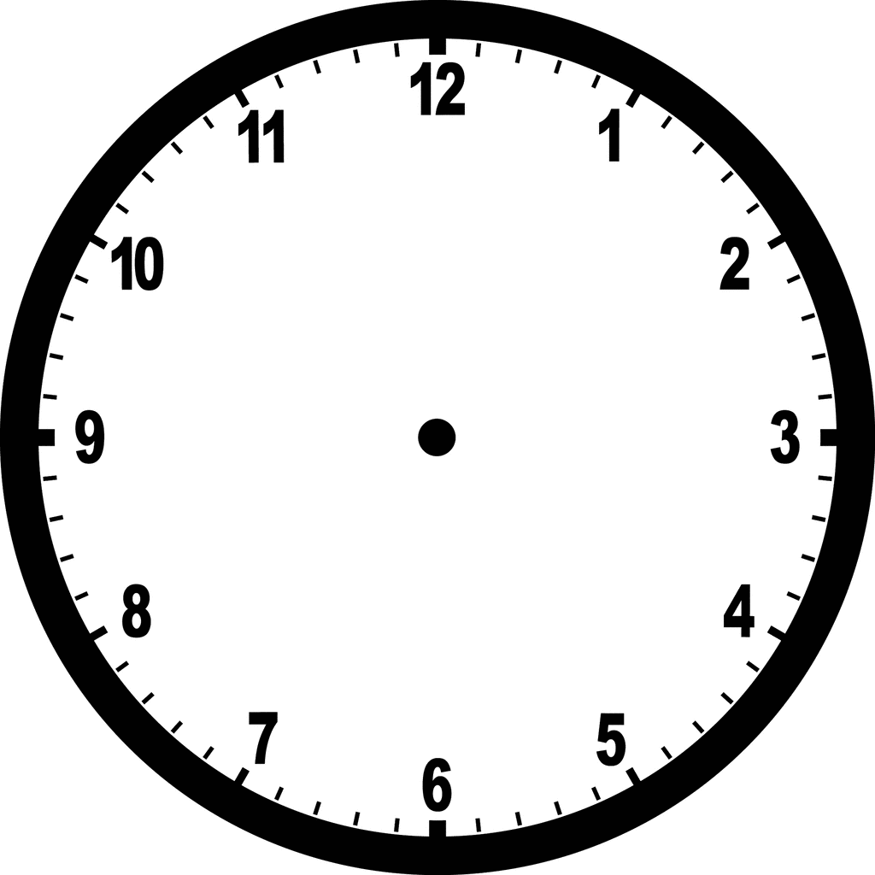
clock

I’ll spell it |  |  | go to 18
 |  |  |  |  |  |  |  | 15
Read out loud the following list from top to bottom.
Read each word/ sentence exactly as written.
I will [insert individual’s ‘yes’ response] to indicate the word I want to say.
Turn to the page number on the right to hear more of my message.
Transport
taxi
bus
car
wheelchair
plane
boat
bike
lorry
I’ll spell it |  |  | go to 18
 |  |  |  |  |  |  |  | 16
Read out loud the following list from top to bottom.
Read each word/ sentence exactly as written.
I will [insert individual’s ‘yes’ response] to indicate the word I want to say.
Turn to the page number on the right to hear more of my message.
Colours
red
blue
green
pink
yellow
orange
purple
grey
black
white
brown
light
dark
I’ll spell it |  |  | go to 18
 |  |  |  |  |  |  |  | 17
.

Insert appropriate alphabet organisation here.

 |  |  |  |  |  |  | 18

Partner Assisted Auditory Scan Book

Adapted from PODD (Porter. G. 2007)

Porter, G. (2007). Pragmatic Organisation Dynamic Display (PODD) communication books: Direct access templates. Melbourne: Cerebral Palsy Education Centre.

