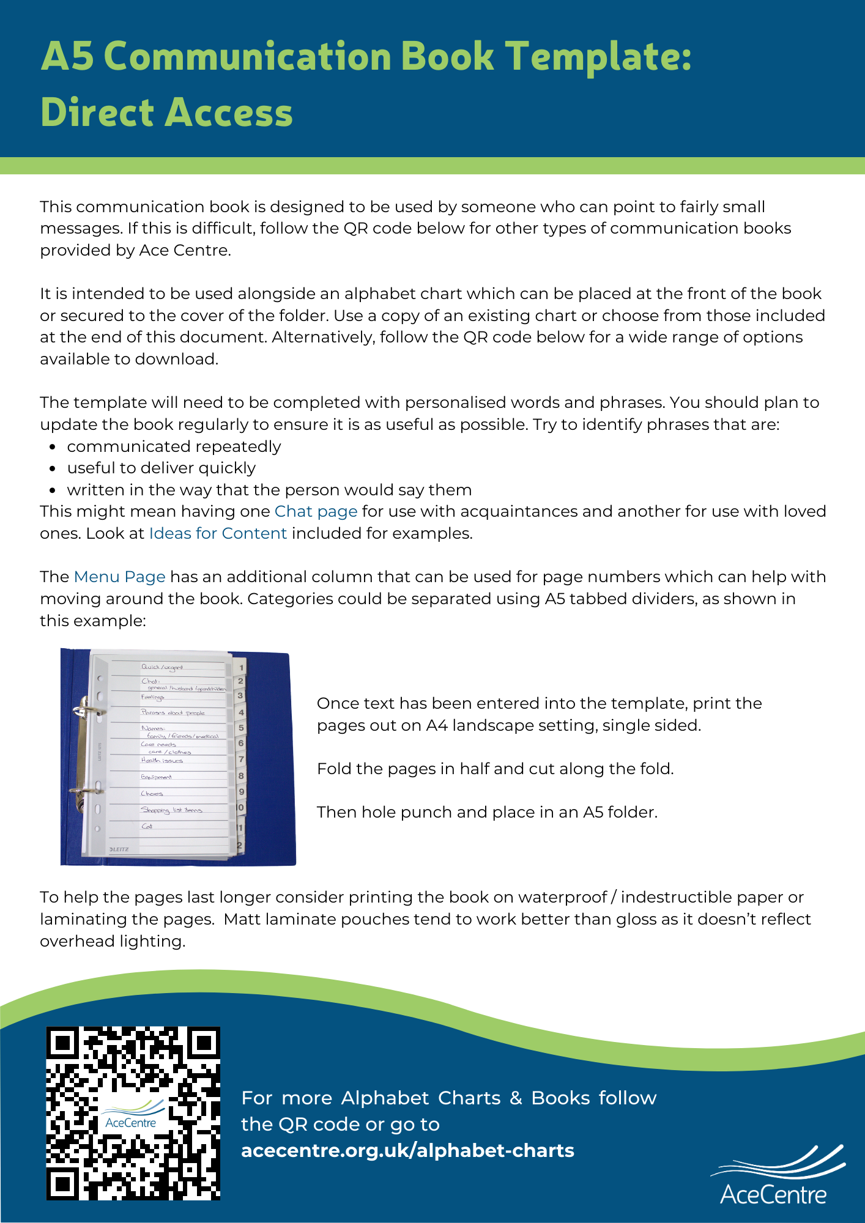
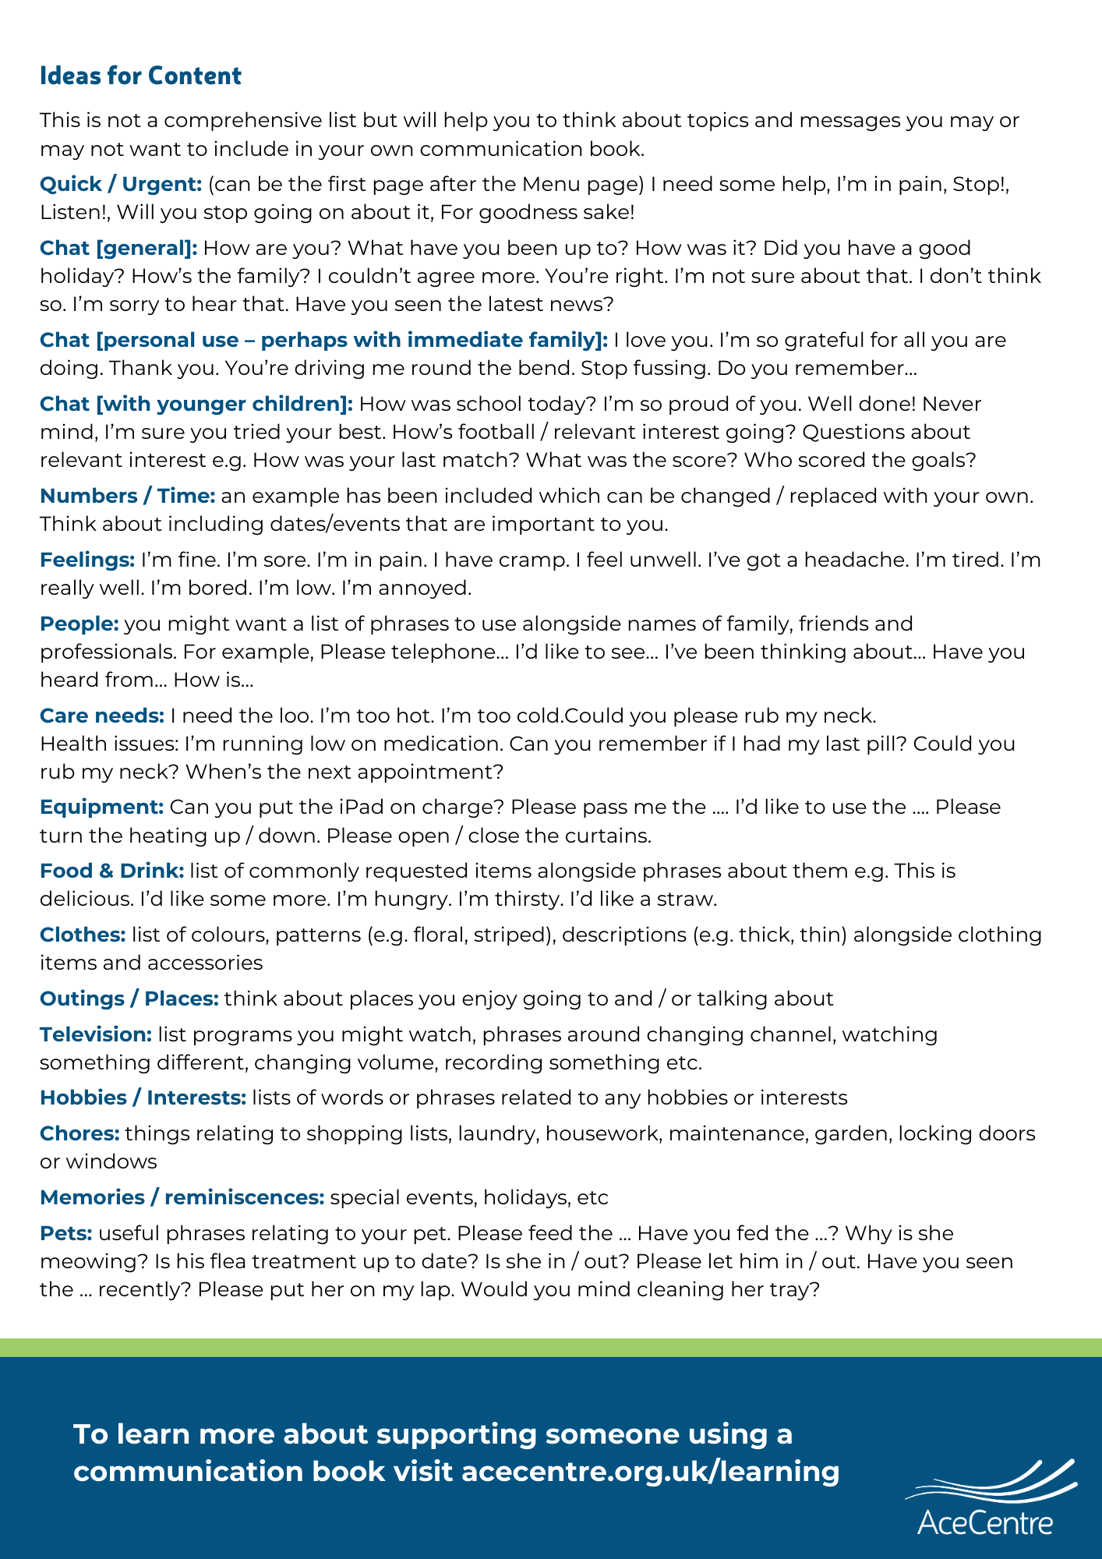

Menu |  |  | Numbers and Time
 |  |  | 0 1 2 3 4 5 6 7 8 9
 |  |  | :00 :15 :30 :45 am pm minutes hours
 |  |  | Monday | Tuesday | Wednesday
 |  |  | Thursday | Friday | Saturday
 |  |  | Sunday | Week | Weekend
 |  |  | Morning | Afternoon | Evening
 |  |  | Breakfast | Lunch | Dinner
 |  |  | January | February | March
 |  |  | April | May | June
 |  |  | July | August | September
 |  |  | October | November | December
 |  |  | Spring | Summer | Autumn
 |  |  | Winter | Next | Last
 |  |  | Birthday | Christmas | Anniversary

Insert Title |  | Insert Title

Insert Title |  | Insert Title

Insert Title |  | Insert Title

Insert Title |  | Insert Title

Insert Title |  | Insert Title

Insert Title |  | Insert Title

Insert Title |  | Insert Title

Insert Title |  | Insert Title

Insert Title |  | Insert Title

Insert Title |  | Insert Title

Insert Title |  | Insert Title

Simple Alphabet Charts
There are many more alphabet charts available to download from acecentre.org.uk

Q | W | E | R | T | Y | U | I | O | P
A | S | D | F | G | H | J | K | L | ?
 | Z | X | C | V | B | N | M | . | !
DELETE |  | SPACE |  |  |  |  |  | START AGAIN

A | B | C | D | E | F | G | H | I | J
K | L | M | N | O | P | Q | R | S | T
U | V | W | X | Y | Z | , | . | ? | !
DELETE |  | SPACE |  |  |  |  |  | START AGAIN

A | B | C | D
E | F | G | H
I | J | K | L
M | N | O | P
Q | R | S | T
U | V | W | X
Y | Z | . | ?
DELETE | SPACE |  | START AGAIN

