
A4 Landscape Core Book
Assembly Instructions:
- Update and change the vocabulary as required.
- Print off each page and then cut round the tab along the bottom that corresponds to the page’s topic.
- Laminate each page, ideally using a matt laminate pouch to avoid reflection from any overhead lighting.
- Cut round the tab again.
- Blind the book together, either along the top edge or the left-hand edge. You could use a comb binder if you have access to one, or a hole punch and treasury tags or loose mental binding rings.
- You should end up with something that looks like this:
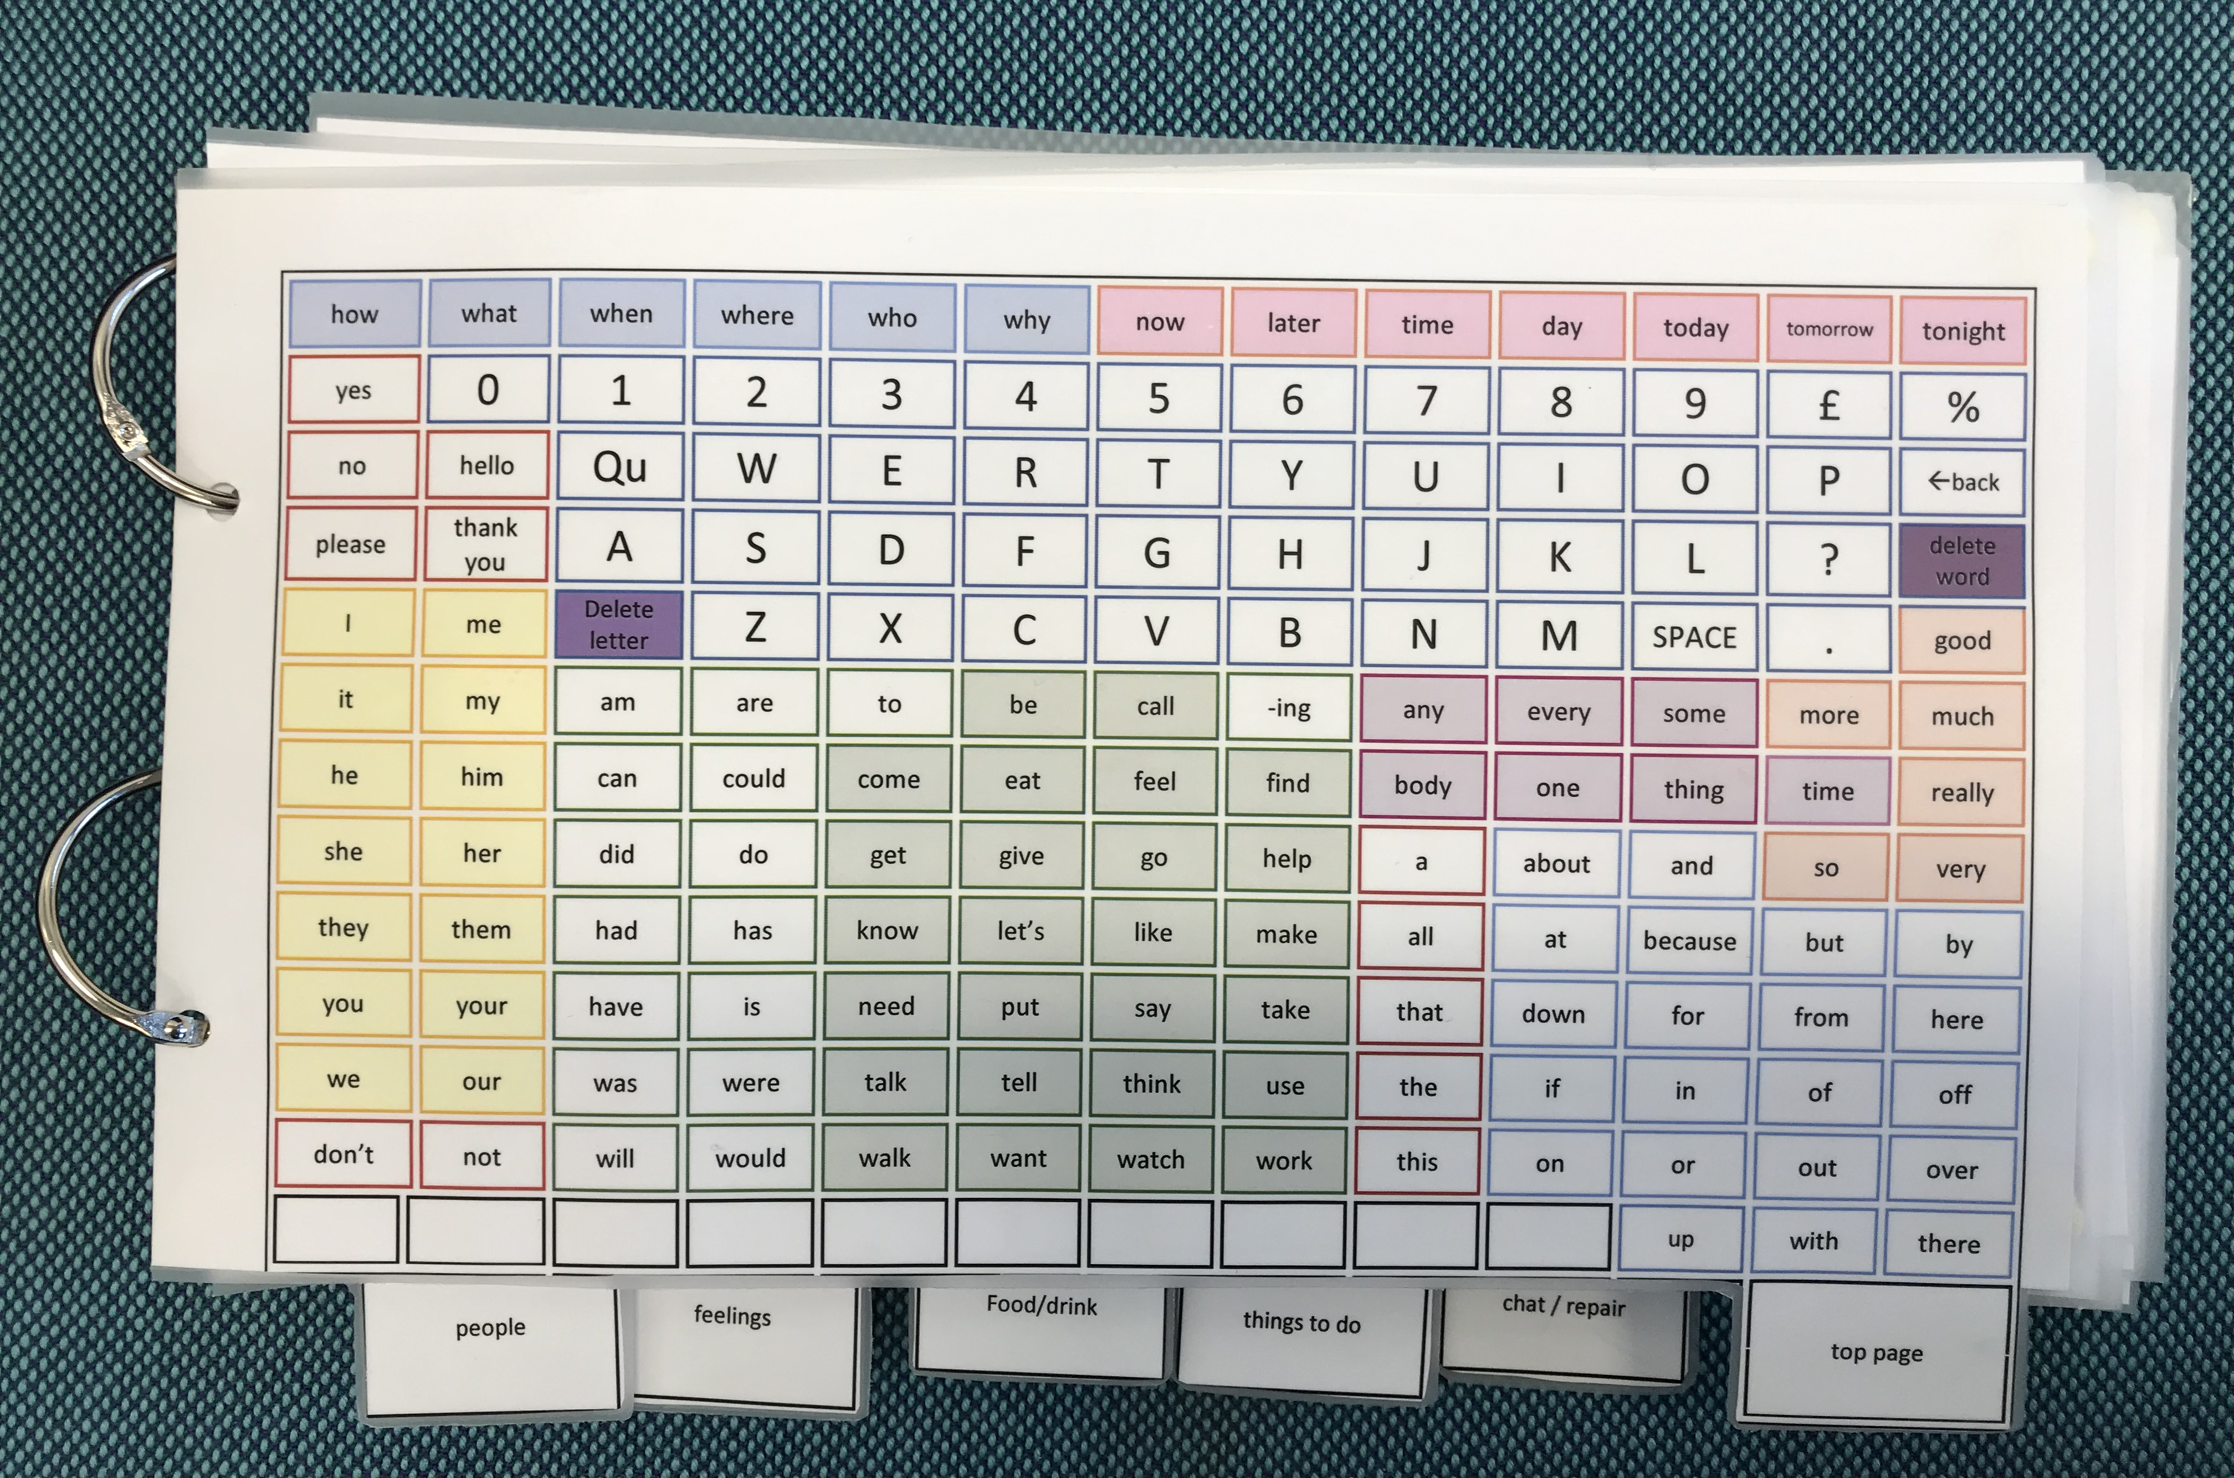

You can view a video of the book being demonstrated on the Ace Centre’s YouTube channel – www.youtube.com/acecentre -
‘A demonstration of a communication book – pointing’. Or you could scan this code to be taken there directly:
how | what | when | where | who | why | now | later | time | day | today | tomorrow | tonight
yes | 0 | 1 | 2 | 3 | 4 | 5 | 6 | 7 | 8 | 9 | £ | %
no | hello | Qu | W | E | R | T | Y | U | I | O | P | ←back
please | thank  you | A | S | D | F | G | H | J | K | L | ? | delete word
I | me | delete letter | Z | X | C | V | B | N | M | SPACE | . | good
it | my | am | are | to | be | call | -ing | any | every | some | more | much
he | him | can | could | come | eat | feel | find | body | one | thing | time | really
she | her | did | do | get | give | go | help | a | about | and | so | very
they | them | had | has | know | let’s | like | make | all | at | because | but | by
you | your | have | is | need | put | say | take | that | down | for | from | here
we | our | was | were | talk | tell | think | use | the | if | in | of | off
don’t | not | will | would | walk | want | watch | work | this | on | or | out | over
 |  |  |  |  |  |  |  |  |  | up | with | there
 |  |  |  |  |  |  |  |  |  | Top Page

Hannah | Matt | Judith | Ellie
Mum | Dad
 |  |  |  |  |  |  |  |  |  |  |  | delete word
person | family | staff | friend | service user | stranger | new person | from the past | someone else | therapist | Dr
 | saw | talk to | email | write to | skype
 | met
 | miss
 | like
don’t | not
People

toast | beans | beans & sausage | cheese | all day breakfast | pasta | spaghetti | macaroni cheese | curry | omelette | soup | pizza | pie
sausage | pork chop | lamb chop | chicken | beef | bacon | burger | sausage roll | faggots | fish cake | fish fingers | fish
Jacket potato | Chips | mashed | waffle | cauliflower | Broccoli | Carrots | Turnip | sprouts | porridge | Weetabix
apple | banana | grapes | pear | rice pudding | cake | trifle | custard | tiramisu | mousse | yoghurt |  | delete word
coffee | juice | milk shake | tea | hot chocolate
food | drink | snack | breakfast | lunch | tea | take-out | meal out | fruit | vegetable
Something else | eat | hot | cold
What do you like? | I like | I ate | let’s have
hungry | full | ate too much! | tasty | horrid
thirsty | drunk
don’t | not
 |  |  |  | Food / Drink

I have a headache | I feel angry | I feel confused | I feel Ok | I feel sad | I feel ill | I feel happy | I feel fed up | I have a pain | Something else
 |  |  |  |  |  |  |  |  |  |  |  | delete word
very | little bit
How are you?
 |  | Feelings

Sports | Bowling | Pub | Baking | shopping | holiday | see Mum |  |  | Watch TV | Sport show | Cookery show | Quiz show
I have an idea | Something else
Who with? | When? | Where? | How long? | How was it? | Where did you go? | What do you think? | I’ll spell it | It’s time to | Let’s go | What day? | What time?
Yes | No | I had fun | I hated it! | Let’s plan | I like | I didn’t like |  |  |  |  |  | delete word
 |  |  |  |  |  | Things to do

Something’s wrong | I want something | I’m telling you something | I’m asking you a question | I can’t find the word | I made a mistake | I’ll start again | Help me find | Not on chart | I’ll spell it | I don’t know | I want to show you | I have more to say
You’re way off | You’re close | Got it | Part of
Hello | Goodbye | Please | Thanks
Excuse me | I’m sorry | I love you | Just joking | Go away |  |  |  |  |  |  |  | delete word
How are you? | What’s happening?
 |  |  |  |  |  |  |  | Chat / Repair

